Abstract

In this paper we have researched articles that are applicable to a system that records vehicle passing data for cyclists. Key areas researched include mobile sensing and Arduino sensing, cyclist safety, cyclist and vehicle interactions, road design. By studying these topics we can gain a better understanding of the technologies we are using and the interactions cyclists have on the road.

Key words

Arduino, sonar, infrared sensor, GPS, mobile sensing,

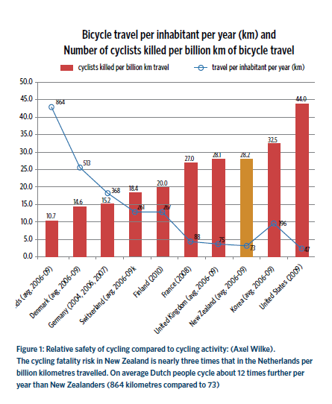

Introduction

Cycling is generally viewed as an environmentally sustainable and economically sustainable mode of transport, but cycling is also much more hazardous. The problems that cyclists face are that drivers are not thinking of cyclists safety, which leads to an increase of crash risk for both cyclists and vehicle users. The graph to the left shows that New Zealand has one of the highest mortality rates in the world among cyclists, this is shocking as the graph also shows New Zealand as being second lowest on cycling hours. Factors that contribute to the problem of cyclist safety are vehicles passing too close to cyclists, and/or passing too quickly. Our hope is to produce a product that produces data that can improve safety for cyclist and road users.

Problem